# **CHAPTER 3**

# **Knee X-ray Image Dataset**

## **3.1 Introduction**

With the respect to the study of this research, the knee X-ray image data sets were used. The data sets were applied to two different studies: (i) knee OA detection where the collected image is divided in two groups (*OA* and *non-OA*) and (ii) knee-OA stage classification where the collected image is divided into five groups (*stage 0* till *stage 4*). The rest of this chapter is organised as follow: the discussion of knee X-ray image collection used in this thesis is presented in Section 3.2. The labelling process for image data sets is discussed in Section 3.3. The description of region of interest (ROI) and image enhancement are commenced in section 3.4. Finally the whole chapter is concluded in section 3.5.

## **3.2 Knee X-ray Image Collection**

A collection of knee X-ray image data set used in this work is discussed in this thesis. A total 131 images were obtained from two local hospitals: (i) Bangkok Hospital (Phuket branch) and (ii) Dibuk Hospital. The image used with respect to the work presented in this thesis was taken in Anterior Postero (AP) position from random age, both male and female, and both left and right. The image was obtained in greyscale colour as Digital Image and Communication on Medicine (DICOM) format. Figure 3.1 shows the AP position original image with DICOM format which the image size was 1416 x 138 pixels.

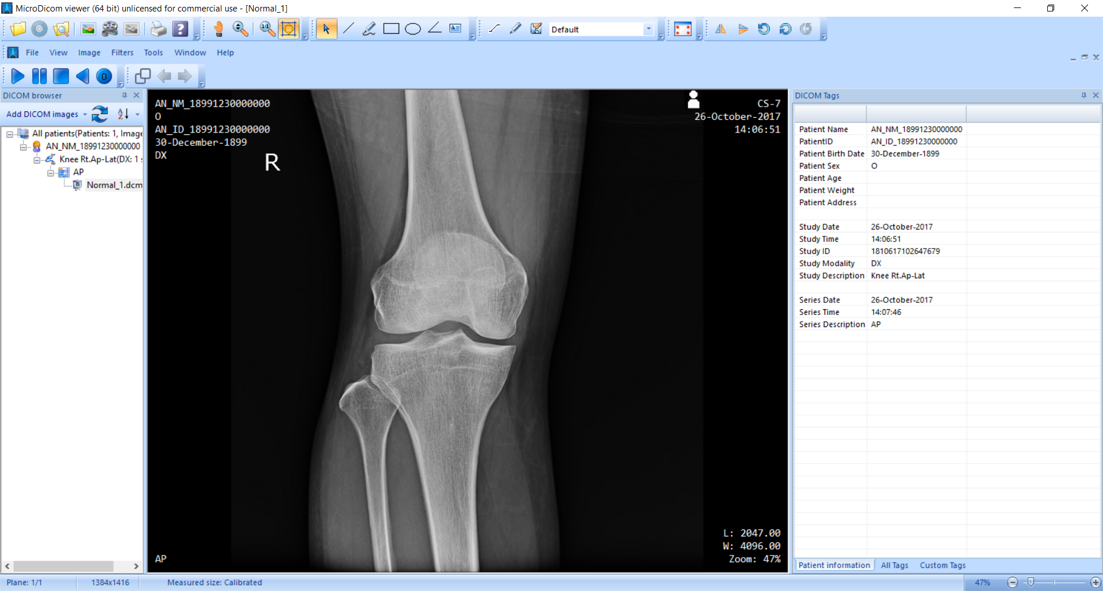

**Figure 3.1** Original X-ray Image in DICOM format which view in DICOM Viewer

Tool.

The obtained image sometime were collected in different positions. The examples X-ray image in Figure 3.2 were eliminated from our data set.

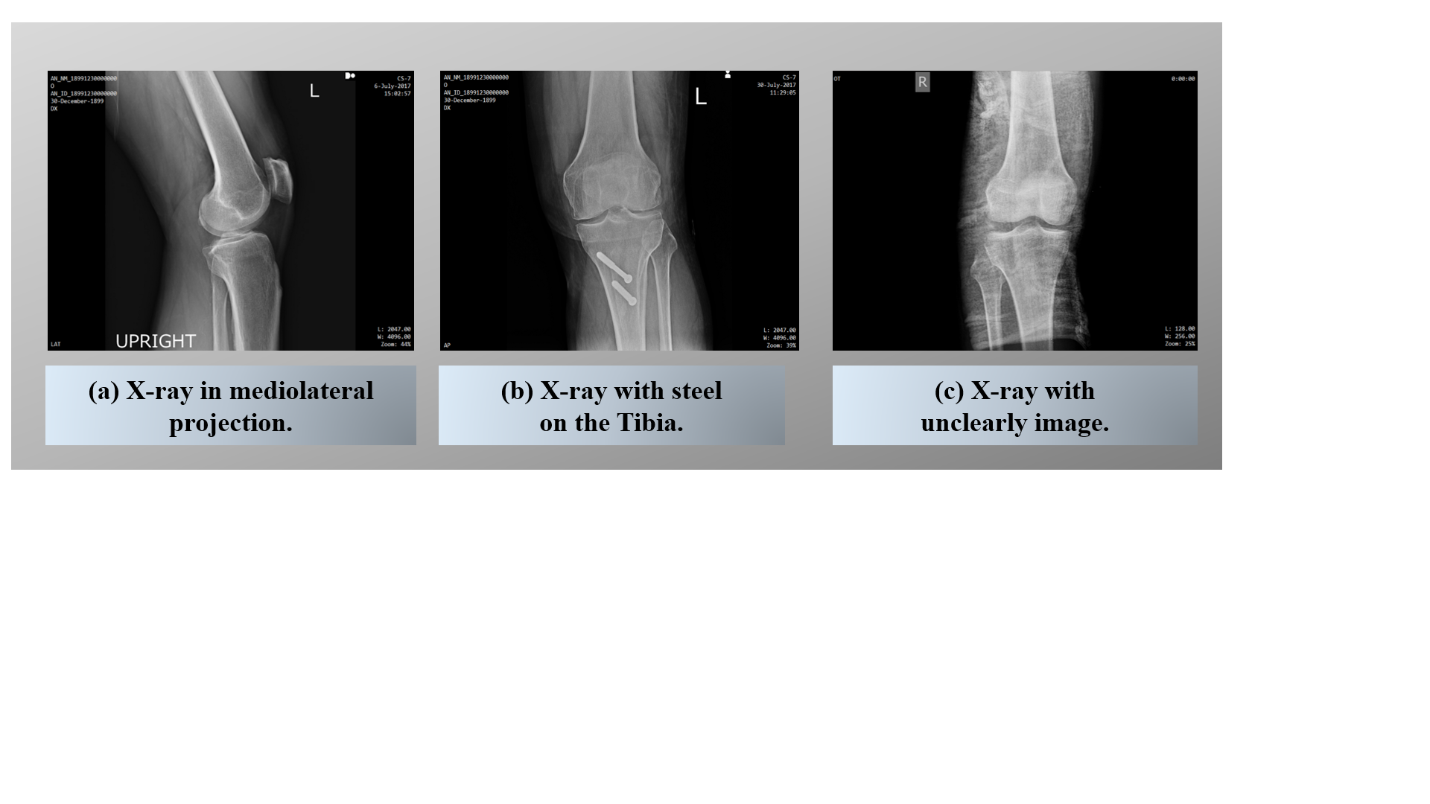

**Figure 3.2** Unselected image

Form the Figure 3.2 it can be seen that, the images were eliminated from the data set presented in Figure 3.2 (a) the image toke in different PA position could not be considered for the study. In Figure 3.2 (b) there is some steel connected with the bone. Thus, in this case the knee-OA cannot analyse because this is not the nature of bone. Finally, Figure 3.2 (c) was eliminated due to some technical error while producing the knee screening image like unclear image.

To prevent the privacy, the collected image were focused only on the image, no personal information was given from the hospital.

## **3.3 Label Image Data Set**

As noted in Chapter 1 Section 1.3 research methodology, there were two different studies had been carried out with respect to the work in this thesis: (i) knee-OA detection and (ii) knee-OA stage classification. Therefore the image data sets were labelled in different ways.

With respect to knee-OA detection, the image data set was separated into two different classes by expert domain from Bangkok Hospital. The classes were: (i) image with OA and (ii) normal control (image without OA) that were presented in Figure 1.1 of Chapter 1. Recall from the Figure 1.1 it illustrated that Figure 1.1 (a) presented the knee without OA, in this figure we can see image with the clear joint space, while Figure 1.1 (b) illustrates the knee with OA, in this figure the knee joint space was disappear from the connected bone. In the study of knee-OA detection, a collected image of 131 images were divided into (i) 63 of normal control image and (ii) 68 of OA image.

With respect to knee-OA stage classification, the Kellgren and Lawrence [16,17] system have level the stage of knee-OA into five different stage (*stage 0* till *stage 4*) as presented in Figure 1.2 of Chapter 1. Recall from Figure 1.2 it can be seen that Figure 1.2 (a) presented the grade 0 or normal control, in this stage there no sign of OA has appeared. Figure 1.2 (b) pictures about the *stage 1* of knee-OA or doubtful stage, in this stage a slightly sing of OA has appeared such as doubtful joint space narrowing. ; Figure 1.2 (c) presented the ~~grade~~ *stage* 2 or Mild grade of knee-OA stage, in this stage the possible joint narrowing was occurred. Figure 1.2 (d) illustrated the ~~grade~~ *stage* *3* or the moderate grade of knee-OA stage, in this stage the joint space reduction and deformity of bone contour were appeared. Lastly, the Figure 1.2 (e) presented the ~~grade~~ *stage* *4* or severe stage, in this stage the great pain when movement was occur to patient and thesis no any joint space more. For knee-OA stage classification study, the 131 collected image of were classified by expert domain from Thongsoung Hospital, Dr. Chaowakon Saehang, MD.

There are three main ways to be consider of knee-OA stage classification based on Dr. Chaowakon with his professional work more than 10 years. These ways include: (i) joint space, (ii) Lateral or Medial condyle, and (iii) the space of Tibia and Femur around the joint space. In Figure 3.3 is illustrated the three ways of OA stages classification by Dr. Chaowakon:

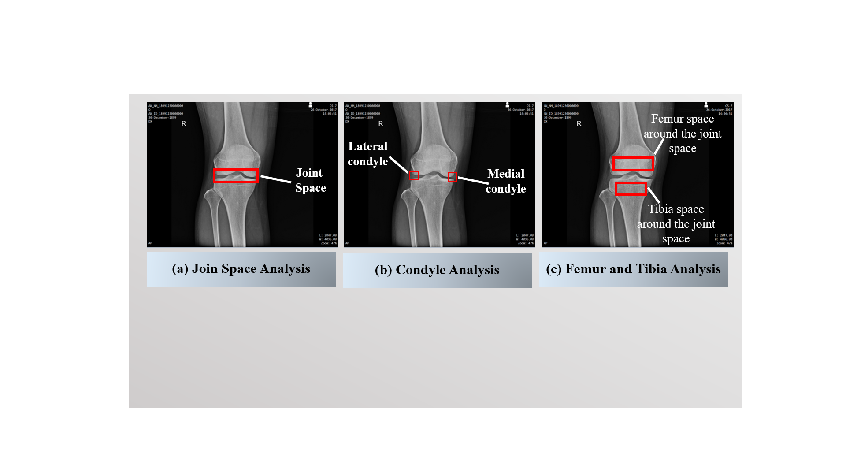

**Figure 3.3** Three Ways of OA stages Classification.

From Figure 3.3 there were three sub-images are illustrated. The Figure 3.3 (a) illustrates the joint space between Femur and Tibia bone (the large and clear join space consider as normal control image but if there is no any joint space it considers as the stage 4 of knee-OA). Figure 3.3 (b) illustrated the way to define knee-OA stages by focusing on both condyle (medial and tibia condyle). If the condyle look not clear and look like brittle, it would be considered to have OA. Finally, Figure 3.3 (c) illustrates the tibia space and femur space around the joint space based on the bone texture analysis.

With respect to the ways that presented by Dr. Chaowakon illustrated in Figure 3.3. Dr. Chaowakon had divided the 131 X-ray images data set in to five group of OA stages as the table below:

**Table 3.1** The number of each OA stage

| OA Stage | *Stage 0* | *Stage 1* | *Stage 2* | *Stage 3* | *Stage 4* |
| --- | --- | --- | --- | --- | --- |
| No. of Images | 39 | 19 | 21 | 44 | 8 |

**Note that: The data set consist of 131 images, due to shape of the bone is not clear I had removed three images of: (i)one image from OA *stage 0* and (ii) two images of *stage 1*. Thus, this set of images is further use shape based presented in Chapter 5 and Chapter 6 respectively.

## **3.4 Region of Interest (ROI) Segmentation and Enhancement**

The mechanism of region of Region of Interest identification and image enhancement are presented in this section. The objective of this process is to identify ROIs from the given image data set and improve the quality of the image so that the feature extraction could be commenced. Sub-section 3.4.1 presents the detail of ROIs used in this thesis. The mechanism used for ROIs quality improvement is discussed in Sub-section 3.4.2.

### 3.4.1 Region of Interest

With respect to the work presented in this thesis, the mechanism of identifying ROIs is presented in this sub-section. ROIs identification was done manually. There are two mechanisms for ROIs identification:

SET A: Four ROIs were identified for texture analysis (Chapter 4). The four ROIs were used in texture analysis include: (i) lateral femur, (ii) medial femur, (ii) lateral tibia, and (iv) medial tibia. Figure 3.4 illustrated the identification of four ROIs:

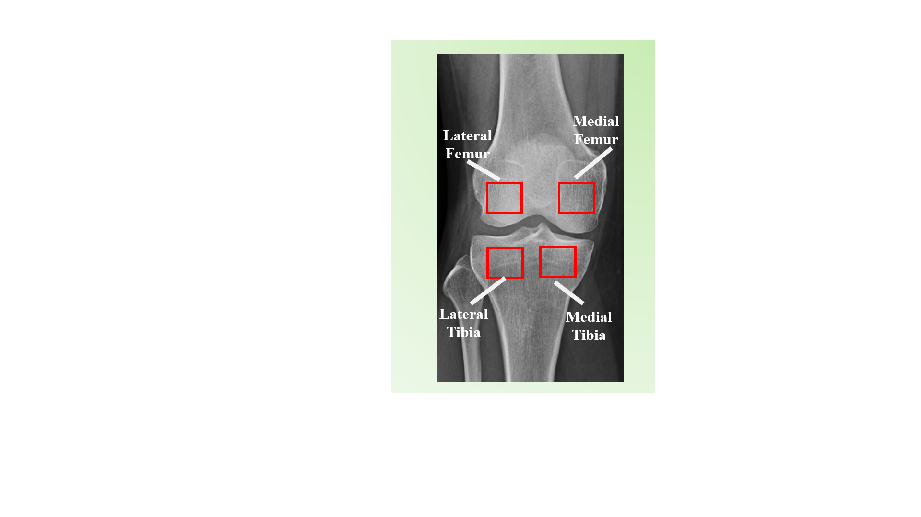

**Figure 3.4** Four different ROIs

SET B: Joint space region was identified for graph-based (Chapter 5) and Convolutional Neural Network (Chapter 6). With respect to graph-based and CNN study, the ROIs identification was focused on knee joint space. There are two ROI were identified: (i) the whole knee ROI, in this ROIs segmented the whole knee cover both tibia and femur region and (ii) knee joint space ROI, in this ROI segmented only the region around joint space. The whole knee ROI and knee joint space ROI are presented in Figure 3.5 below:

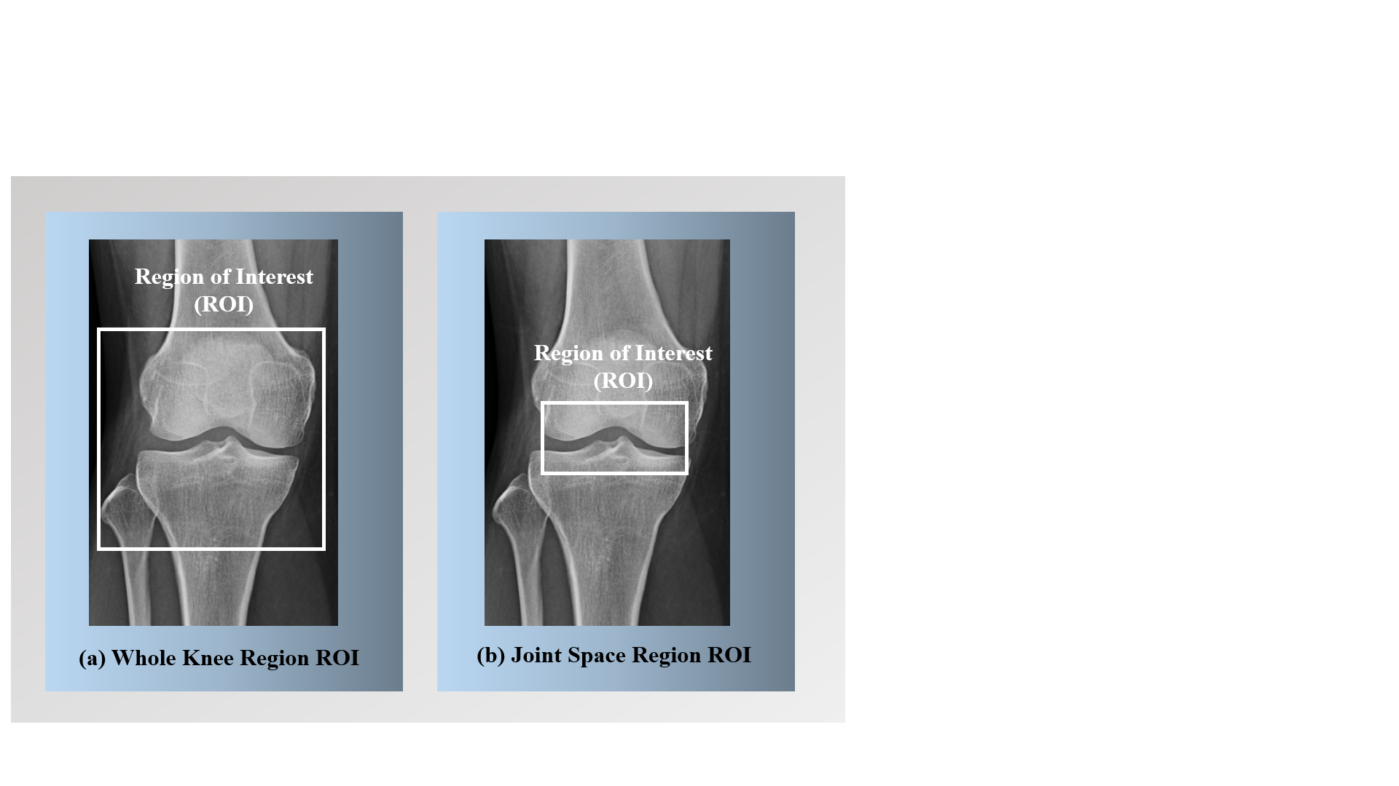

**Figure 3.5** ROIs of joint space area

With reference to Figure 3.5, there two ROIs are presented in shape based approach. Figure 3.5 (a) illustrated the whole knee ROI, in this region cover of condyle and region around the joint space. Figure 3.5 (b) presented the joint space. The segmentation of ROI were presented in this section. Next, the enhancement techniques is applied in joint space ROI.

### 3.4.2 ROI Image Enhancement

With respect to the work presented in this thesis, the mechanism of identifying ROIs is presented in this sub-section. ROIs identification was done manually. There are two mechanisms for ROIs identification:

Once the ROIs had been identified, the image enhancement could be performed. With respect to the work presented here, the Otsu thresholding was applied to the obtained ROIs. The detail of Otsu was presented in Chapter 2 Section 2.3. The objective of the process is to improve the quality of image, thus to be ready in the feature extraction process. The Otsu thresholding was applied only in ROIs of joint space area to make the joint gap clearer in order to facilitate in shape analysis. The Figure 3.6 is represented the example of Otsu operator:

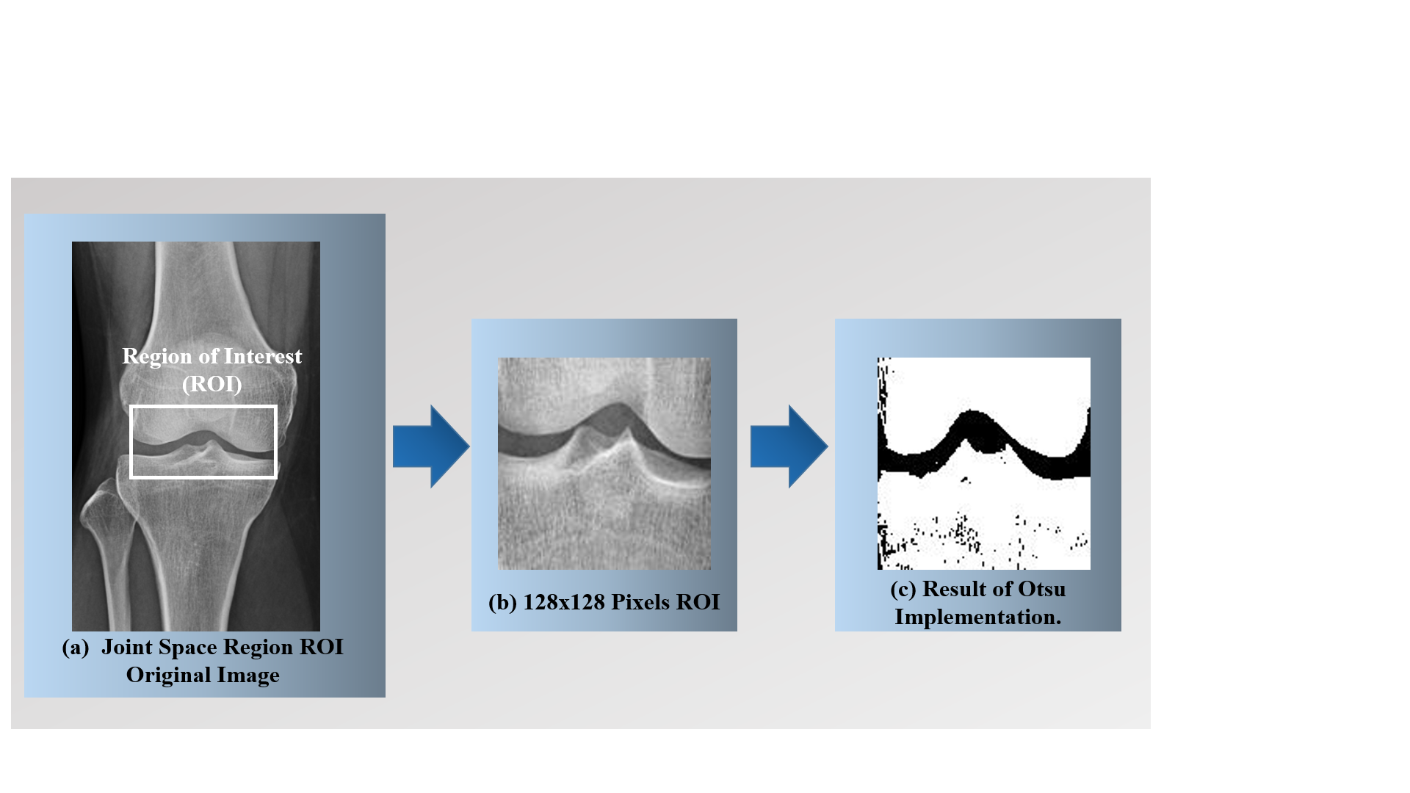

**Figure 3.6** The example of Otsu operator to knee joint gap area

From Figure 3.6 it can be seen that the original image with knee joint gap ROI identification is presented in Figure 3.6 (a). Figure 3.6 (b) illustrated the 128x128 pixel ROI of knee joint gap area and Figure 3.6 (c) illustrated the result Otsu operator applying to Figure 2.3 (b).

## **3.5 Summary**

In summary, this chapter presented on X-ray image data set that used in this thesis work. The chapter focused the data set collection and the ROIs identification for each image of data set that is suitable to use in the next process of the research work. The way to label the data set for use in the research was presented in this chapter. Finally, pointed out the enhancement technique for improvement the ROI quality.